BAPTISM OF CHILDREN
INFORMATION
AND
APPLICATION FORM

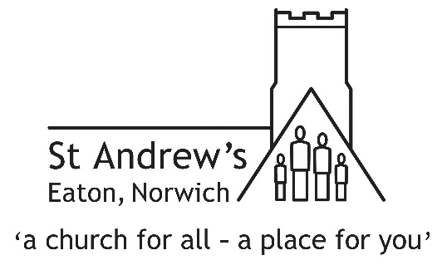

GREAT NEWS!
We are delighted that you have decided to have your child baptised. This is a big decision, and we are eager that all concerned should be clear about what is involved. That’s what this leaflet is all about…
BAPTISM – WHAT IT MEANS
Baptism is the first step by which God takes us into a special relationship of love and service. We are made members of the Church, and agree to follow the teaching and ways of Jesus.
In the Baptism service, parents and godparents have to reply to a series of questions, saying that they turn away from sin, that they turn to Christ as saviour, and that they trust in him Christ as Lord.
They also make the Christian profession of faith in God: Father, Son and Holy Spirit.
Both parents and godparents should have a sincere intention that the child to be baptised should be helped and encouraged to be a practising Christian, and when he/she is old enough, be confirmed as a full member of the Church of England.
In the meantime, though, it is important that you should all be attending church services. At St Andrew’s there are a number of services at different times specifically aimed at families with children. Have a word with Phil Rodd, the Vicar, for more details of our services.
GODPARENTS
Those who are baptised as infants normally have at least three godparents. At least two of them should the same sex as the infant and one of the opposite sex. If it proves impossible for there to be three godparents it is possible for a baptism to take place with one godfather and one godmother. Parents can be godparents to their own children, providing there is at least one other godparent as well.
In order that they can fulfil their role as guides and examples of the faith, godparents need be able to make the declarations and promises in the baptism service, which is why the Church of England requires all godparents to be baptised themselves and normally to be confirmed as well. That is also why it is not possible for a member of a non-Christian faith to be a godparent.
WHERE TO GET BAPTISED
Normally the best plan is to have your child baptised in the parish where you live and where he/she will grow up. There may, however, be special reasons for having the baptism elsewhere; in which case, simply mention this to the vicar, Phil Rodd, when you first make contact – or as soon after as possible. We will then check with your local church to make sure that the minister there knows what is happening and approves of it.
PREPARATION FOR BAPTISM
The minister taking the service (usually the vicar, Phil Rodd) will arrange two or three meetings, to discuss the service and any more complex questions. In addition, you will normally be visited a few weeks before the baptism by one or two members from St Andrew’s. The intention is that they will provide a link and support for you on the actual day of the baptism and also deal with any questions and concerns of a general nature. They will contact you beforehand to arrange a date to meet up with you.

NORMAL SUNDAY SERVICES AT ST ANDREW’S

8 am Holy Communion (BCP)

10 am Morning Worship (1st & 3rd Sundays)
Holy Communion (2nd, 4th & 5th Sundays)
(all 10 am services have full provision for children)

6.30 pm Informal Evening Service (1st Sunday only)

There’s lots more happening at St Andrew’s.
For more information, speak with the Phil Rodd, the Vicar,
or visit our website: www.standrewseaton.org.uk

See also the Christenings section
of the Church of England website:
www.churchofengland.org/life-events/christenings

Vicar: Rev Phil Rodd
Tel: 01603 455778
Email: rev.phil@standrewseaton.org.uk

Eaton Parishes Office
41 Church Lane Eaton Norwich NR4 6NW

Jul 2021

